Developing a Machine Learning Application

Monet Paul
Study.com
Computer science 311
01/29/2025

Name and Purpose of the Application
How do we can predict prices for commodities? With enough data, AI can make this prediction for us. Honey scanner is an app that predicts the price of honey based on the characteristics of the honey.

Algorithms Used
The machine learning algorithm chosen is linear regression. “Supervised learning is a machine learning task, where you have input variable x (features) and output variable Y (labels) pairs and you use an algorithm to learn the mapping function from the input to the output.” (Supervised Learning in Machine Learning | Study.com, n.d.) Neural networks weren't my choice because of their language-centric algorithms, which are inappropriate for the task. Based on the dataset of honey, it has many X values or features that will determine the price value. I avoided support vector machines because of their application in complex tasks such as face detection and bioinformatics.

Dataset Information
I found my dataset from Kaggle by Umair Zia. The name of the dataset is Predict Purity and Price of Honey. From Kaggle, the number of records is over 200K (), and the number of features is 11. The first feature is Color Score as CS which is a float data type ranging from 1.0 to 10.0, where lower scores represent a lighter color of the honey sample and higher scores for a darker color. Density is a float between 1.21 and 1.86, signifying the honey's density. The next feature is water content, denoted as WC, where it’s a float data type with a range of 12.0% to 25.0% representing the water content in the honey. pH represents the honey’s pH level as a float data with a range of 2.50 to 7.50. Electrical conductivity, as EC, in the set which represents electrical conductivity of the honey as a float and no range. F as fructose level as float data type with a range of 20 to 50 which represents the honey’s fructose level. G as glucose level as float data type with a range of 20 to 45, which represents the honey’s glucose level. Pollen_analysis feature is a string data type which represents the honey’s floral source. Viscosity is a float, and the range is between 1500 and 10000 and represents the honey’s viscosity. “Viscosity values between 2500 and 9500 are considered optimal for purity.” (Predict Purity and Price of Honey, 2024) Purity is a float data type which ranges from 0.01 to 1.00. The feature is the price which is a float data type and shows the price of the honey.
In the preprocessing step, I remove duplicates. Before removing duplicates, the shape was 247,903 rows and 11 columns, and after it had the same number using the shape function from pandas. The same results happen with removing any missing values. The reason why I have the same result is that more than likely, the person who created the data cleaned it as well .The data is clean.

Libraries, Toolkits, and Frameworks
Anaconda and Jupyter are used to see what is going on with each line of code or code sections by showing the results. Pandas are used to clean and prepare the data. SciKit-Learn is used to get the algorithm for the model. In addition, also train and test the model with SciKit-Learn.
Application Design and Implementation
The workflow starts with pandas being imported. It reads the dataset, which is part of the loading stage. The app will first show the shape of the data which is how many records and the number of columns. Next is the cleaning/preparing stage, where the app will convert the pollen_ analysis value into a number for the linear regression model since it only takes numbers and not strings or characters. It will clean the data by removing duplicates and missing values in the dataset. During the train/test split phase, the system will divide the data, allocating 80% for training and setting aside 20% for testing predictions. The model will next be in training, then testing the predictions. It will show all the predictions. For the stage of evaluation, it will show the mean squared error and R-Squared score.

Instructions For Running The App
To execute the code in VS Code, you need to install pandas(command: pip install pandas), the current version of python( version 3.14.2), SciKit-Learn(command: pip install scikit-learn)and the Python extension (under extension in VS where it’s called Python) to your computer. Press Crtl or Command then press Shift and P. Next type new Jupyter and click Create new Jupyter notebook.
The easier way to execute the code is to install Anaconda and pick JupyterLab 4.4.7 in the anaconda navigation.
Next, put the code section by section, and there are comments in the main.py where it says “section…”. Screenshots will be below showing the setup and results. Just press the double triangle next to the word “code” at the top for Anaconda. Then for VS code you press “run all”.

Results
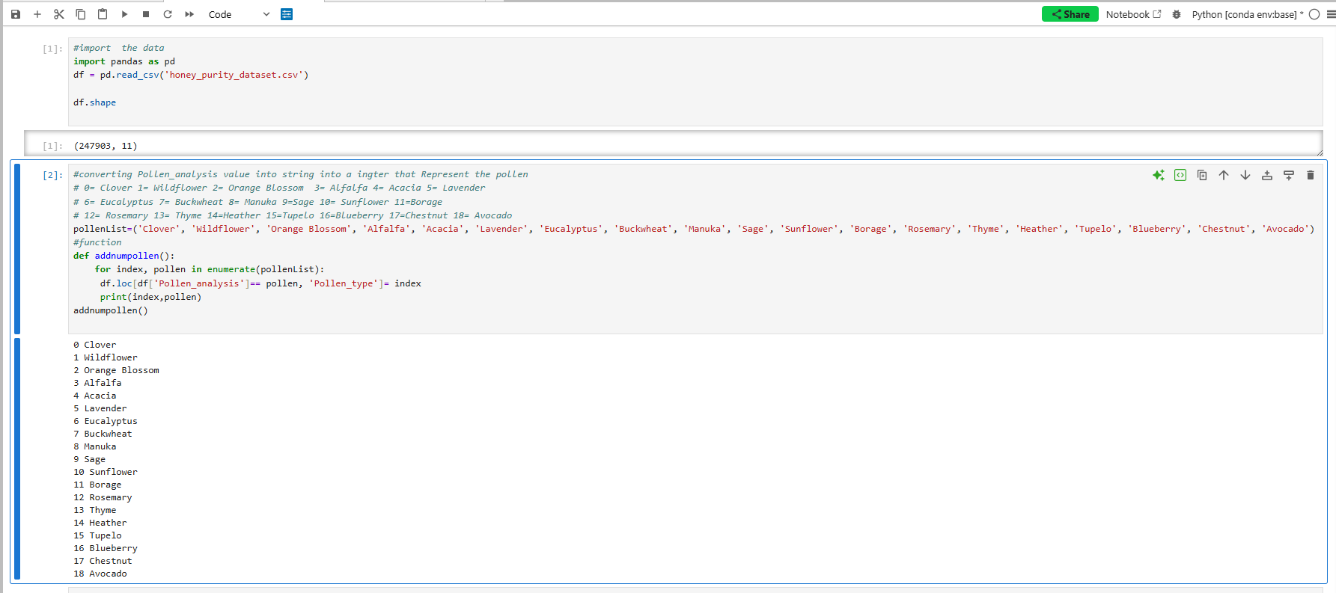
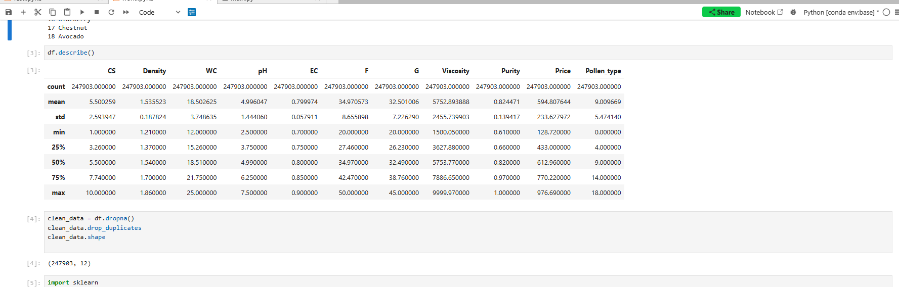
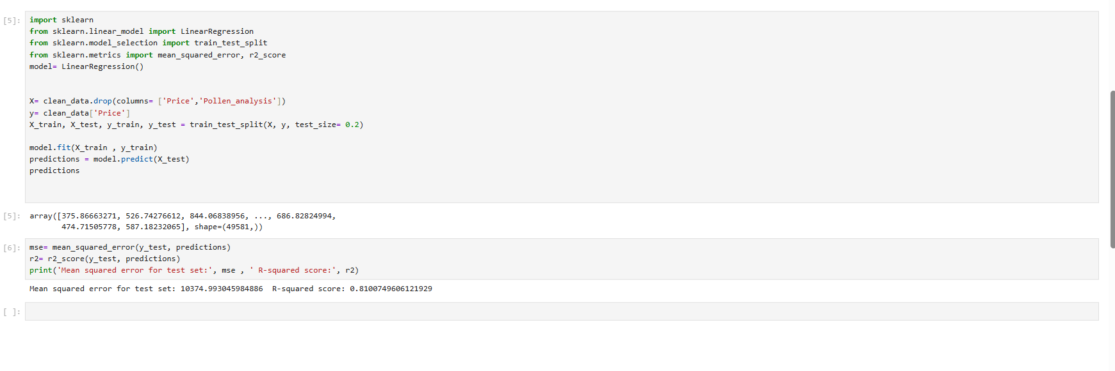

Discussion And Insights
The Honey scanner app's purpose is for honey price prediction. When I first ran the model, I got around 0.18 for the R-squared score, and when I ran it again, it was around 0.81 as the result. It was around 0.80 for the third time. The performance of the model based on the R-squared score is good since the second and third times are close to 1. I think the fluctuation is more so from not running all the cells; it was just more so I got the 0.18 when I was still working on the logic. I got around 10, 372.36 on the mean squared error. The limitation is the mean squared error because there is no way to know if it’s well. “MSE measures the average squared difference between predicted and actual values, penalizing larger errors more heavily. MAE calculates the average absolute difference, treating all errors equally regardless of their magnitude.” (Introduction to SciKit-Learn: Building Simple Machine Learning Models | Study.com, n.d.) From this lesson and many others in the course, don’t explain the number itself from mean squared error compared to r squared. It raises the question of what is low for a data size of over 200,000 and with a price ranging from 128.72 to 976.69. I think to improve the model that predicts more accurately and have a better way to measure its accuracy by picking a different model. I learned so much from this project.

References
Anaconda. (2026, January 7). Advance AI with Open Source | Anaconda. https://www.anaconda.com/
Introduction to Scikit-Learn: Building Simple Machine Learning Models | Study.com. (n.d.). study.com. https://study.com/academy/lesson/introduction-to-scikit-learn-building-simple-machine-learning-models.html
pandas documentation — pandas 3.0.0 documentation. (n.d.). https://pandas.pydata.org/pandas-docs/stable/index.html
Predict Purity and Price of Honey. (2024, February 18). https://www.kaggle.com/datasets/stealthtechnologies/predict-purity-and-price-of-honey
Project Jupyter. (n.d.). Home. https://jupyter.org/
Python - Visual Studio Marketplace. (n.d.). https://marketplace.visualstudio.com/items?itemName=ms-python.python
scikit-learn: machine learning in Python — scikit-learn 1.8.0 documentation. (n.d.). https://scikit-learn.org/stable/index.html#
Supervised Learning in Machine Learning | Study.com. (n.d.). study.com. https://study.com/academy/lesson/supervised-learning-in-machine-learning.html
Visual Studio Code - The open source AI code editor. (2021, November 3). https://code.visualstudio.com/
Welcome to Python.org. (2026, January 26). Python.org. https://www.python.org/

